Wireshark Lab: ICMP
INSTRUCTIONS:
1) USE THE DEVICE NAMING FORMAT AS MENTIONED IN BELOW TOPOLOGY
(First 4 letters of First Name)(Initial of Last Name)_SW1
2) ATTACH FULL SCREENSHOTS WITH ALL THE DETAILS INCLUDED.
3) WRITE YOUR FULL NAME AND SMU ID NUMBER ON THE SUBMISSION FILE AS
WELL AS THE GNS3 TOPOLOGY.
4) USE THE EXACT SAME TOPOLOGY AS PROVIDED.
5) SUBMIT THE ASSIGNMENT BEFORE THE PROVIDED DUE DATE.
6) MAKE SURE YOU LEARN AND UNDERSTAND ALL THE CONCEPTS WHILE YOU PERFORM THE ASSIGNMENT.

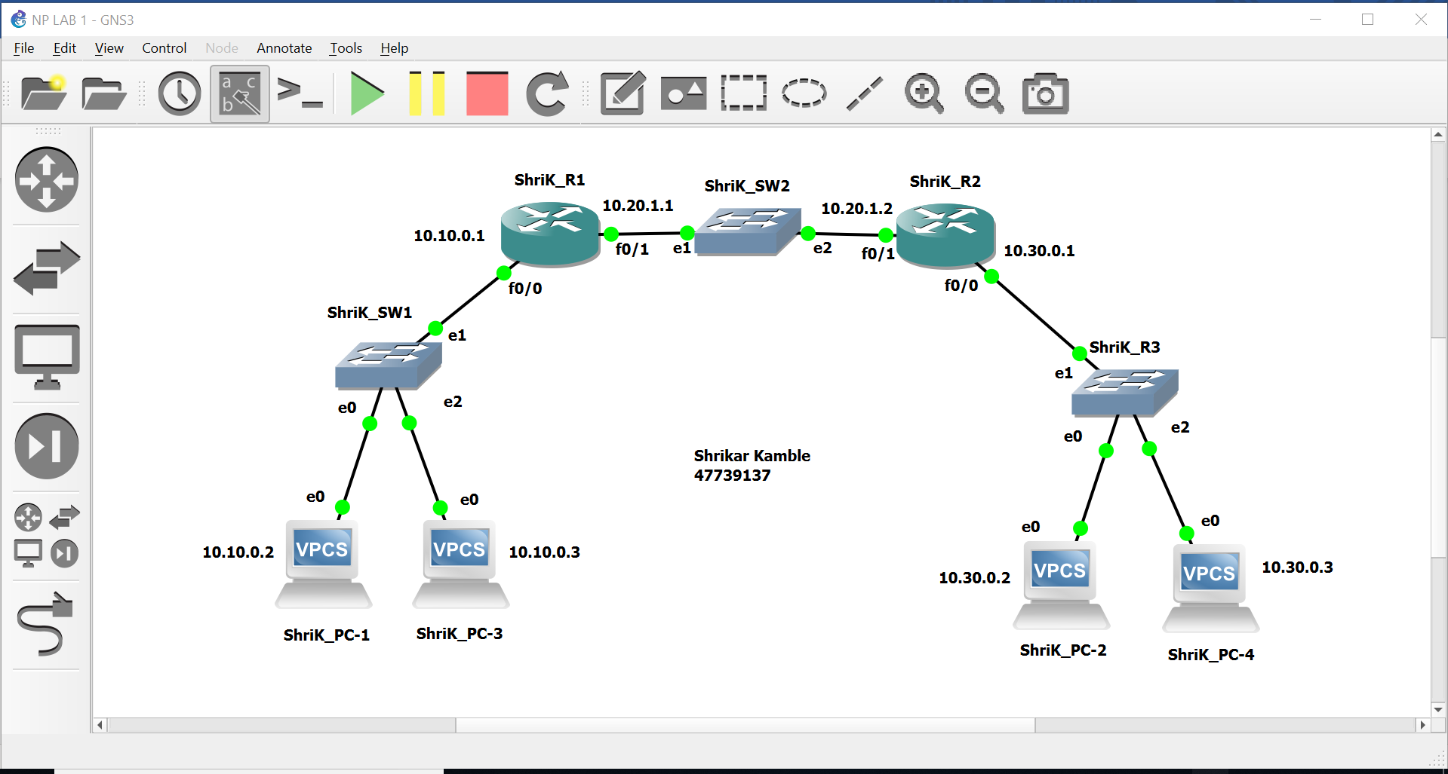

1) Create a similar topology. Rename all the routers as per the format given in topology above.
2) Connect all the links as shown and configure the given IP addresses.
3) Configure static routes on routers R1 and R2.
All the configurations to be done in global config mode of routers.

In this lab, we’ll explore several aspects of the ICMP protocol:

- ICMP messages generating by the Ping program;
- ICMP messages generated by the Traceroute program;
- the format and contents of an ICMP message.

1. ICMP and Ping

Let’s begin our ICMP adventure by capturing the packets generated by the Ping program. You may recall that the Ping program is simple tool that allows anyone (for example, a network administrator) to verify if a host is live or not. The Ping program in the source host sends a packet to the target IP address; if the target is live, the Ping program in the target host responds by sending a packet back to the source host. As you might have guessed (given that this lab is about ICMP), both of these Ping packets are ICMP packets.

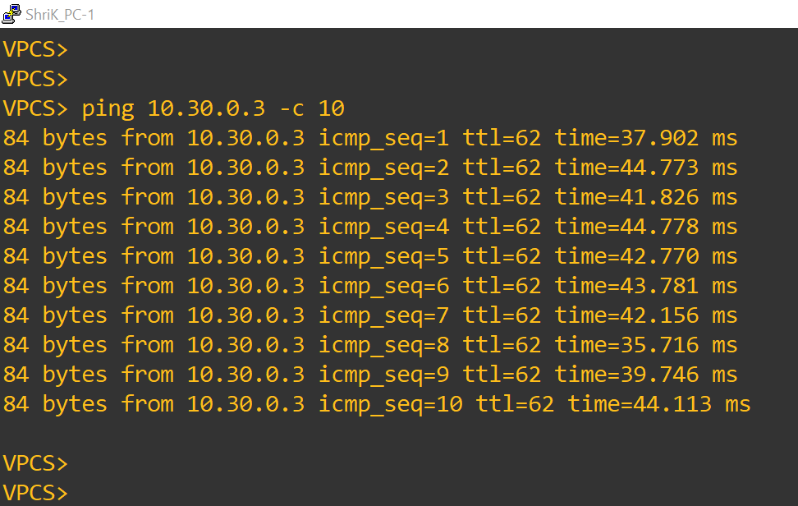

Figure 1: Ping result from PC-1 to PC-2

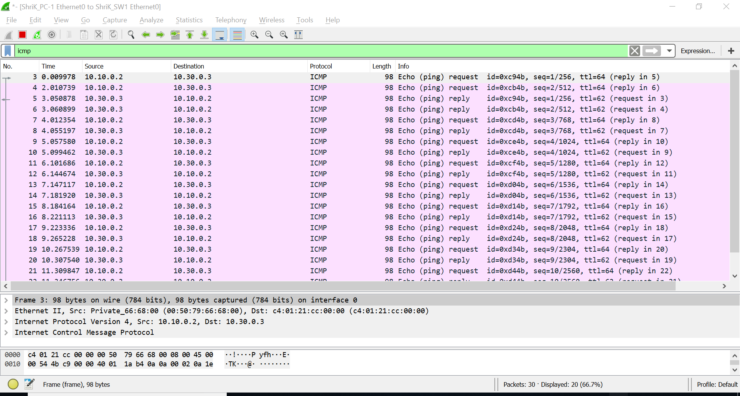

Figure 2 Wireshark output for Ping program with Internet Protocol.

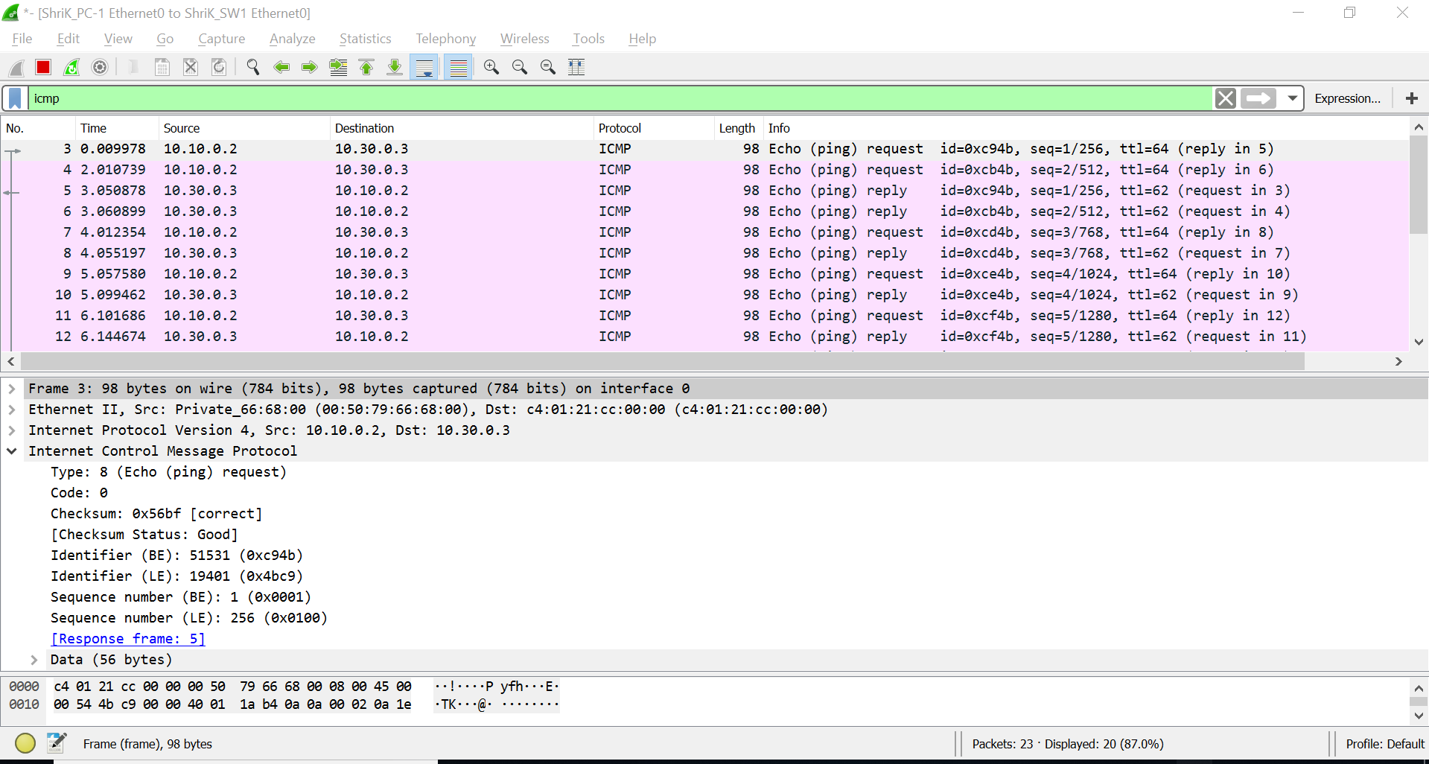

Figure 3: Wireshark capture of ping packet with ICMP packet expanded.

Do the following:
- Configure a static route on R1 to reach 10.30.0.0 network. Also configure a static route on R2 t reach 10.10.0.0 network.
- Start a Wireshark capture on link between PC-1 and Switch-1
- Ping from PC-1 to PC-4
- When the Ping program terminates, stop the packet capture in Wireshark.

What to Hand In:
Submit screen shots for successful ping result from PC-1 to PC-4 and Wireshark output displaying the packets captures during ping.

You should answer the following questions:

- What is the IP address of your host? What is the IP address of the destination host?
- Why is it that an ICMP packet does not have source and destination port numbers?
- Examine one of the ping request packets sent by your host. What are the ICMP type and code numbers? What other fields does this ICMP packet have? How many bytes are the checksum, sequence number and identifier fields?
- Examine the corresponding ping reply packet. What are the ICMP type and code numbers? What other fields does this ICMP packet have? How many bytes are the checksum, sequence number and identifier fields?

2. ICMP and Traceroute
Let’s now continue our ICMP adventure by capturing the packets generated by the Traceroute program. You may recall that the Traceroute program can be used to figure out the path a packet takes from source to destination. Traceroute is discussed in Section
  - and in Section 4.4 of the text.

Traceroute is implemented in different ways in Unix/Linux and in Windows. In Unix/Linux, the source sends a series of UDP packets to the target destination using an unlikely destination port number; in Windows, the source sends a series of ICMP packets to the target destination. For both operating systems, the program sends the first packet with TTL=1, the second packet with TTL=2, and so on. Recall that a router will decrement a packet’s TTL value as the packet passes through the router. When a packet arrives at a router with TTL=1, the router sends an ICMP error packet back to the source. In the following, we’ll use the native Windows tracert program. A shareware version of a much nicer Windows Traceroute program is pingplotter (www.pingplotter.com). We’ll use pingplotter in our Wireshark IP lab since it provides additional functionality that we’ll need there.

Do the following:

    - Let’s begin by opening the Windows Command Prompt application (which can be found in your Accessories folder).
    - Start up the Wireshark packet sniffer, and begin Wireshark packet capture.
    - The tracert command is in c:\windows\system32, so type either “tracert hostname” or “c:\windows\system32\tracert hostname” in the MS-DOS command line (without quotation marks), where hostname is a host on another continent. (Note that on a Windows machine, the command is “tracert” and not “traceroute”.) If you’re outside of Europe, you may want to enter www.inria.fr for the Web server at INRIA, a computer science research institute in France. Then run the Traceroute program by typing return.

If you are unable to run Wireshark live on a computer, you can download the zip file http://gaia.cs.umass.edu/wireshark-labs/wireshark-traces.zip and extract the file ICMP-ethereal-trace-2. The traces in this zip file were collected by Wireshark running on one of the author’s computers, while performing the steps indicated in the Wireshark lab. Once you have downloaded the trace, you can load it into Wireshark and view the trace using the File pull down menu, choosing Open, and then selecting the ICMP-ethereal-trace-2 trace file. You can then use this trace file to answer the questions below.
- When the Traceroute program terminates, stop packet capture in Wireshark.

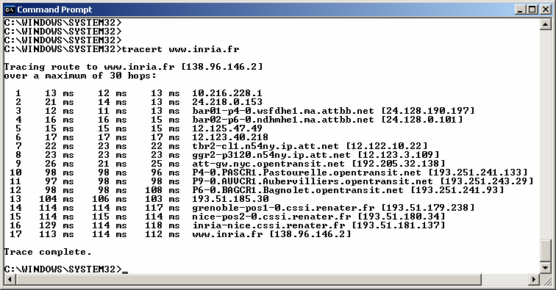
At the end of the experiment, your Command Prompt Window should look something like Figure 4. In this figure, the client Traceroute program is in Massachusetts and the target destination is in France. From this figure we see that for each TTL value, the source program sends three probe packets. Traceroute displays the RTTs for each of the probe packets, as well as the IP address (and possibly the name) of the router that returned the ICMP TTL-exceeded message.
Figure 4 Command Prompt window displays the results of the Traceroute program.
Figure 5 displays the Wireshark window for an ICMP packet returned by a router. Note that this ICMP error packet contains many more fields than the Ping ICMP messages.
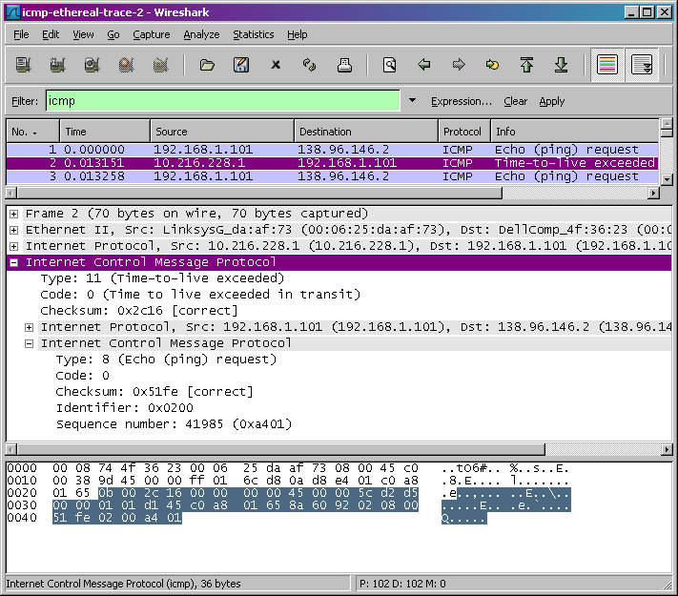

Figure 5 Wireshark window of ICMP fields expanded for one ICMP error packet.

What to Hand In:

For this part of the lab, you should hand in a screen shot of the Command Prompt window. Whenever possible, when answering a question below, you should hand in a printout of the packet(s) within the trace that you used to answer the question asked. Annotate the printout to explain your answer. To print a packet, use File->Print, choose Selected packet only, choose Packet summary line, and select the minimum amount of packet detail that you need to answer the question.

Answer the following questions:

  - What is the IP address of your host? What is the IP address of the target destination host?
  - If ICMP sent UDP packets instead (as in Unix/Linux), would the IP protocol number still be 01 for the probe packets? If not, what would it be?
  - Examine the ICMP echo packet in your screenshot. Is this different from the ICMP ping query packets in the first half of this lab? If yes, how so?
  - Examine the ICMP error packet in your screenshot. It has more fields than the ICMP echo packet. What is included in those fields?
  - Examine the last three ICMP packets received by the source host. How are these packets different from the ICMP error packets? Why are they different?
  - Within the tracert measurements, is there a link whose delay is significantly longer than others? Refer to the screenshot in Figure 4, is there a link whose delay is significantly longer than others? On the basis of the router names, can you guess the location of the two routers on the end of this link?

Lab Report

Write a minimum of two type-written pages with a minimum of 12-point font describing what you learned in the lab. Do NOT simply repeat the steps you performed, summarize the purpose of the lab by explaining the concepts covered.

Your lab report will be submitted automatically to turnitn.com when you submit it to Canvas. You do not need to do anything besides submit the assignment to Canvas. Be sure you write your report in your own words. Although you may work with other to compete the lab procedure, your report MUST be your original work.

